Python Page Builder

Run the python script titled ‘pageBuilder.py’ or any of the compiled .exe file

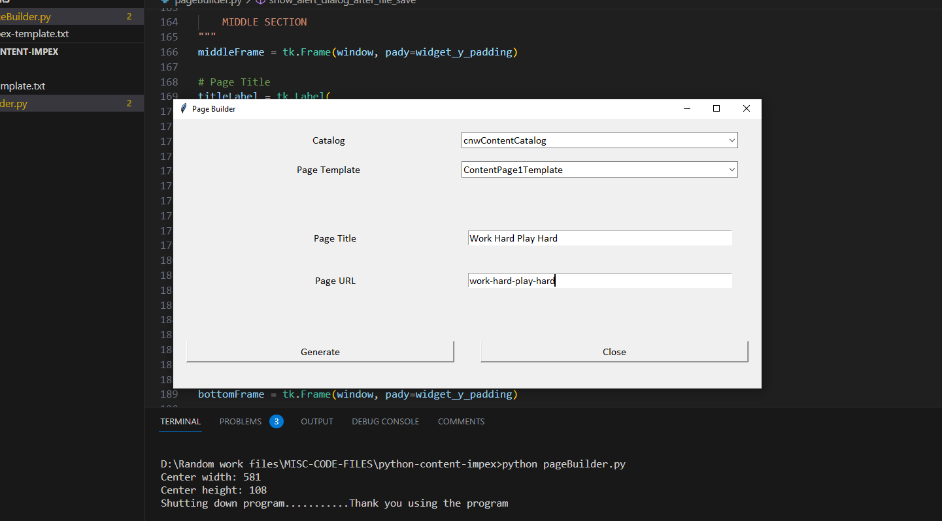

|  |  |
| --- | --- |
| Catalog | Select drop-down list which contains content catalogs |
| Page Template | Select drop-down list for WCMS page template |
| Page Title | User should enter page title |
| Page URL | User should enter the url alias for page title |

Once the ‘Generate’ button is clicked, a File Save dialog window will be opened and give the user the option to save/create an Impex file in the desired location.

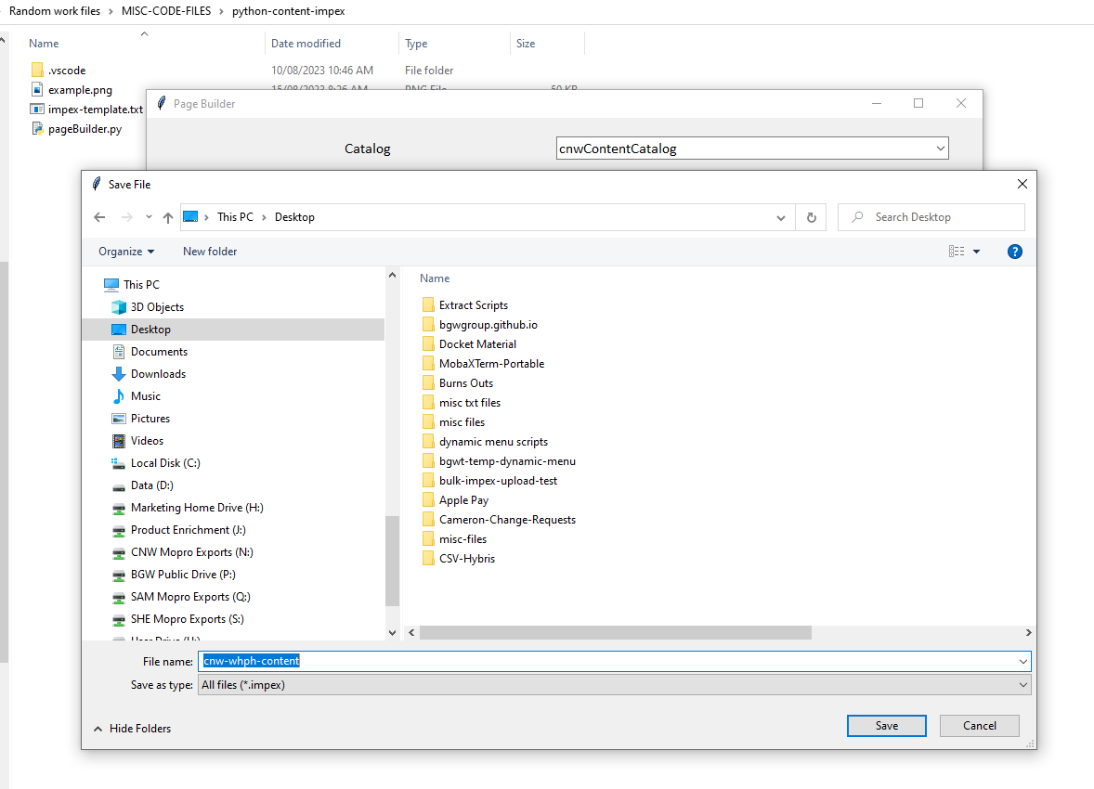

Once the Impex file is generated, a dialog will appear to state that the file has been saved.

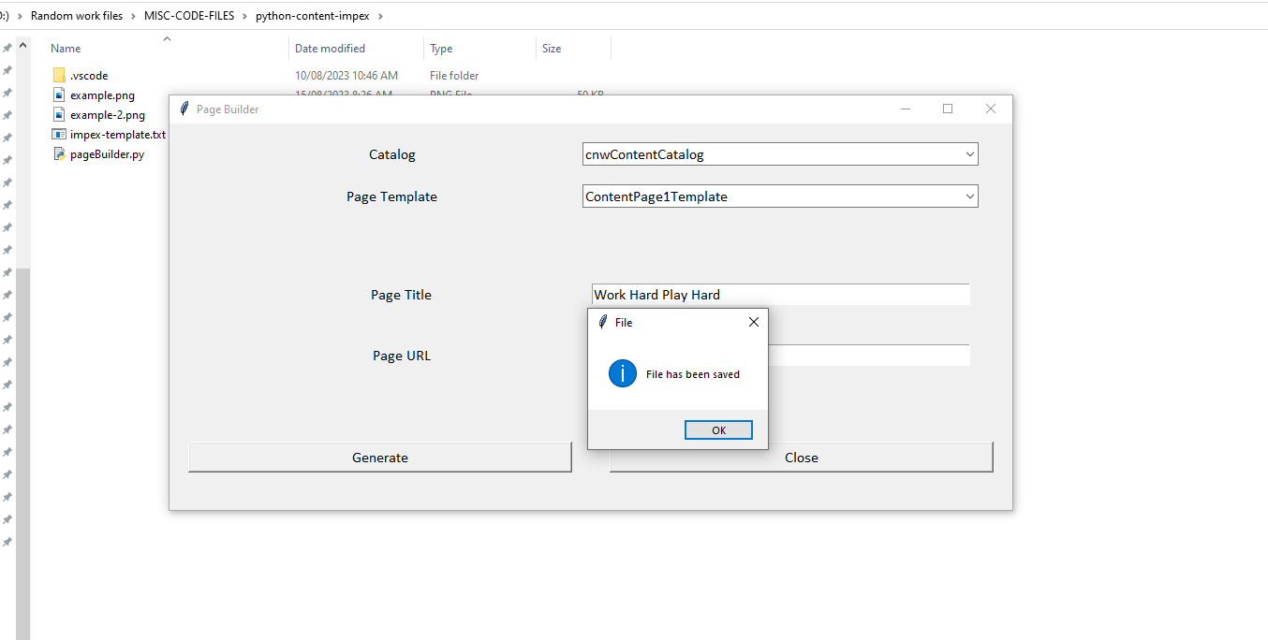

Example of the output file

#=================================================================================================================================

#================================================ STAGED ==================================================

#=================================================================================================================================

# Macros / Replacement Parameter definitions

$contentCatalog=cnwContentCatalog

$version=Staged

$contentCV=catalogVersion(CatalogVersion.catalog(Catalog.id[default=$contentCatalog]),CatalogVersion.version[default=$version])[default=$contentCatalog:$version]

$picture=media(code, $contentCV);

$image=image(code, $contentCV);

$media=media(code, $contentCV);

$page=page(uid, $contentCV);

$contentPage=contentPage(uid, $contentCV);

$siteResource=jar:au.com.cnw.initialdata.setup.InitialDataSystemSetup&/cnwinitialdata/import/sampledata/contentCatalogs/$contentCatalog

$jarResourceCms=jar:au.com.cnw.initialdata.setup.InitialDataSystemSetup&/cnwinitialdata/import/cockpits/cmscockpit

# Language

$lang=en

INSERT_UPDATE ContentPage;$contentCV[unique=true];uid[unique=true];name;title;masterTemplate(uid,$contentCV);label; defaultPage[default='true']; approvalStatus(code)[default='approved']; homepage[default='false'];previewImage(code, $contentCV)

;;workhardplayhardpage;Work Hard Play Hard;Work Hard Play Hard;ContentPage1Template;work-hard-play-hard;;;;

INSERT_UPDATE CMSParagraphComponent;$contentCV[unique=true];uid[unique=true];name;&componentRef;visible[default='true'];content[lang=en]

;;workhardplayhardparagraph;Work Hard Play Hard;workhardplayhardparagraph;true;"Content"

INSERT_UPDATE ContentSlot;$contentCV[unique=true];uid[unique=true];name;active;cmsComponents(&componentRef)

;;CenterContentSlot-workhardplayhard;Center Content Slot for workhardplayhard;true;workhardplayhardparagraph

;;RightContentSlot-workhardplayhard;Right Content Slot for workhardplayhard;true;

;;LeftContentSlot-workhardplayhard;Left Content Slot for workhardplayhard;true;

INSERT_UPDATE ContentSlotForPage;$contentCV[unique=true];uid[unique=true];position[unique=true];page(uid,$contentCV)[unique=true];contentSlot(uid,$contentCV)[unique=true]

;;CenterContent-workhardplayhard;CenterContent;workhardplayhardpage;CenterContentSlot-workhardplayhard

;;RightContent-workhardplayhard;RightContent;workhardplayhardpage;RightContentSlot-workhardplayhard

;;LeftContent-workhardplayhard;LeftContent;workhardplayhardpage;LeftContentSlot-workhardplayhard

#=================================================================================================================================

#================================================ ONLINE ==================================================

#=================================================================================================================================

# Macros / Replacement Parameter definitions

$contentCatalog=cnwContentCatalog

$version=Online

$contentCV=catalogVersion(CatalogVersion.catalog(Catalog.id[default=$contentCatalog]),CatalogVersion.version[default=$version])[default=$contentCatalog:$version]

$picture=media(code, $contentCV);

$image=image(code, $contentCV);

$media=media(code, $contentCV);

$page=page(uid, $contentCV);

$contentPage=contentPage(uid, $contentCV);

$siteResource=jar:au.com.cnw.initialdata.setup.InitialDataSystemSetup&/cnwinitialdata/import/sampledata/contentCatalogs/$contentCatalog

$jarResourceCms=jar:au.com.cnw.initialdata.setup.InitialDataSystemSetup&/cnwinitialdata/import/cockpits/cmscockpit

# Language

$lang=en

INSERT_UPDATE ContentPage;$contentCV[unique=true];uid[unique=true];name;title;masterTemplate(uid,$contentCV);label; defaultPage[default='true']; approvalStatus(code)[default='approved']; homepage[default='false'];previewImage(code, $contentCV)

;;workhardplayhardpage;Work Hard Play Hard;Work Hard Play Hard;ContentPage1Template;work-hard-play-hard;;;;

INSERT_UPDATE CMSParagraphComponent;$contentCV[unique=true];uid[unique=true];name;&componentRef;visible[default='true'];content[lang=en]

;;workhardplayhardparagraph;Work Hard Play Hard;workhardplayhardparagraph;true;"Content"

INSERT_UPDATE ContentSlot;$contentCV[unique=true];uid[unique=true];name;active;cmsComponents(&componentRef)

;;CenterContentSlot-workhardplayhard;Center Content Slot for workhardplayhard;true;workhardplayhardparagraph

;;RightContentSlot-workhardplayhard;Right Content Slot for workhardplayhard;true;

;;LeftContentSlot-workhardplayhard;Left Content Slot for workhardplayhard;true;

INSERT_UPDATE ContentSlotForPage;$contentCV[unique=true];uid[unique=true];position[unique=true];page(uid,$contentCV)[unique=true];contentSlot(uid,$contentCV)[unique=true]

;;CenterContent-workhardplayhard;CenterContent;workhardplayhardpage;CenterContentSlot-workhardplayhard

;;RightContent-workhardplayhard;RightContent;workhardplayhardpage;RightContentSlot-workhardplayhard

;;LeftContent-workhardplayhard;LeftContent;workhardplayhardpage;LeftContentSlot-workhardplayhard